**Newsletter No. 226 September to November 2017**

Dear Member,

Welcome to all our new members, we look forward to seeing you at some of our future events in the autumn. Our forthcoming lectures in September and October, details inside this newsletter, depict aspects of the theatrical world popular in the 19th and early 20th centuries, and the artistry evoked by that medium.

The highlight of our year, has been the 51st Annual Summer Exhibition. Congratulations to all artists for producing such varied and talented works, much appreciated, I gather, from the effusive comments in our visitors book by everyone who popped in. Thanks also to my fellow Committee members and our team of helpers and stewards without whose efforts and support the exhibition could not be held. Our opening Luncheon, the first of our two social functions during the year, was thoroughly enjoyed by the nearly 60 members and guests who joined us.

Once more this year, students from two local colleges, the University of Hatfield and West Herts College submitted works from their final year studies. This time, they displayed concept items as well as very interesting and unusual paintings. We were pleased to be able to support them again as it is so important to encourage young artists who will, in the future, carry on innovation and change that is inevitable in revitalising art in the 21st century.

Our visit to Hever Castle which I had the pleasure to lead on a very warm day, was enjoyed by all. The castle itself is small and the art of little merit but the other attractions on site, vintage car shows, a Ferrari exhibition etc etc, and the grounds themselves, kept everyone happy despite the vast crowds Our last visit to Clarence House which I also led was heavily subscribed and the guided tour albeit short was both informative and entertaining. Again, I believe all who came along went away happy.

Please note (and please diarise!) Our Christmas Festive Supper will again be at Porters Park Golf Club. Application forms and details will be in the November Newsletter.

Best wishes to all**. Garry Hersh**

**FUTURE LECTURES at the Radlett Centre**

|  |
| --- |
| ***REMINDER Thursday 7th September 7.30pm for 8pm***  https://upload.wikimedia.org/wikipedia/commons/thumb/b/b1/Henri_de_Toulouse-Lautrec_012.jpg/1024px-Henri_de_Toulouse-Lautrec_012.jpg**TOULOUSE-LAUTREC &**  **MUSIC HALLS OF PARIS**  **Lecturer & Art Historian:**  ***Dr. Peter Webb BA MA(Cantab) PHD***  ***Admission: Members Free***  ***Non-Members ₤8. Coffee is available.*** |

**LUNCHTIME LECTURE *tTuesday 3rd October 2017***

**Admission – free to all 12 noon for 1.00pm start**

ELLEN TERRY and THE AESTHETES

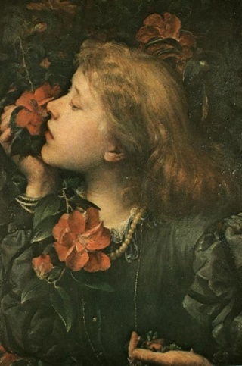***Dame Alice Ellen Terry***, [***GBE***](https://en.wikipedia.org/wiki/Order_of_the_British_Empire)**(1847-1928)** known professionally as ***Ellen Terry*** was the leading [***Shakespearean***](https://en.wikipedia.org/wiki/Shakespeare)***actress*** in Britain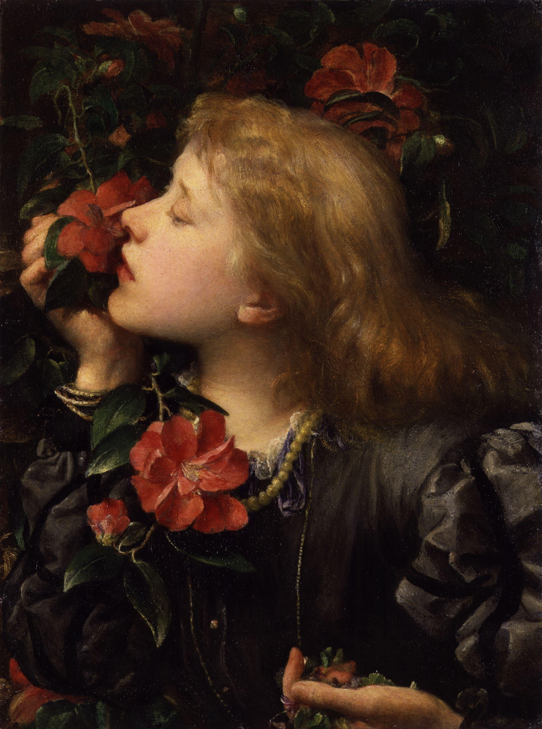, enjoying a career lasting almost seven decades. Born into a family of actors, she

made her first stage appearance as **Mamillius**, at the age

of nine opposite **Charles Kean** at *the*  ***Princess’s Theatre,***

London, in Shakespeare’s **The Winter’s Tale.**

She continued to perform throughout her teens and later

in London also touring the provinces. In 1878 she joined

**Henry Irving’s** company as his leading lady and for over

twenty years was lauded as the leading Shakespearean

and comic actress in Britain. They also toured with much

success in America as well as Britain.

In a long and successful career, she workeduntil her final ***“Choosing*:”,**

retirement from the stage in 1920, but still appeared in [***George Frederic Watts***](https://en.wikipedia.org/wiki/George_Frederic_Watts)***, c. 1864***

films from 1916 until 1922. She died in 1928

**Lecturer**

***FRANCES HUGHES***

**REFRESHMENTS ARE AVAILABLE FROM THE TEATRO RESTAURANT**

JOHN BLAND

It is with sadness we report the death of JOHN BLAND who, for many years was an active member of the Society. He was an excellent painter whose works were

much admired by us and visitors alike at our annual Exhibitions. He suffered a progressive blindness in later life, which he bore with great courage. His many friends in the Society will remember him with much affection.

**PAST LECTURES**

**PAST LECTURES**

**Thursday 11th May Frank Woodgate BA** lectured on **FRANCIS BACON**

Francis Bacon, named after his ancestor Sir Francis Bacon, was born in Dublin in 1909. His relationship with his father was tense, and ended when he was expelled from the family home at the age of sixteen. He drifted aimlessly, travelling between London, Paris and Berlin until in his twenties he became involved in furniture and interior design. One of his patrons encouraged him to take up oil painting which he developed through the 1930s. His breakthrough came in the mid-1940s when his work was recognised and appreciated universally. The depression and bleak outlook, evident in his work, was attributed to those early unhappy years. Frank Woodgate’s sympathetic understanding of this controversial artist guided us beyond the grotesque and showed the brilliant colours and precise drawings of his works that had so much meaning in them. An Interesting and thought-provoking evening **Margaret Follett**.

**Thursday 15th June Rosalind Whyte BA (HONS) MA** lectured on

**ANTONY GORMLEY & ANISH KAPOOR**

Rosalind demonstrated that there are many similarities between these two sculptors, which are far from obvious from an initial perusal of their works. They were both born in the 1940s, studied art in London in the 1970s and have been lauded and honoured by the Establishment. Where the differences lie are in the abstraction of Kapoor’s works against the human forms of Gormley’s. But, as Rosalind said, Kapoor bases his pieces on organic forms and both base their ideas on similar philosophies. From a Buddhist perspective, Kapoor looks at the space around and shows how it is always deceptive, while Gormley’s figures become part of the landscape and deceive the viewer into thinking they are animate. It was really interesting to see the development, through a wide variety of slides, of two current, highly acclaimed, practitioners**. Muriel Beaver**

**Thursday 10th August Dr. Colin Bailey** lectured on **PIETER BREUGHEL**

As usual, Colin’s lecture was scholarly and informative, covering the short, but productive life of Brueghel (b.1525-1530, d. 1569). Brueghel travelled widely in Europe, so was familiar with Renaissance painting. On his return to the Low Countries, he settled in Antwerp, where he produced landscape drawings for prints, heavily influenced by Hieronymus Bosch and, later, moved to Brussels and concentrated on painting. The earlier pictures depict huge numbers of peasants within a landscape, viewed from a high point, whereas his later works show fewer figures with a background landscape. His moral standpoint and humour were greatly admired by eminent patrons and collectors in his day and have remained popular ever since.  **Muriel Beaver**

**FUTURE VISITS**

**REMINDER Full details in the previous newsletter**

***SUNDAY 24TH SEPTEMBER SNOWHILL MANOR and GARDENS* Depart outside old Radlett Post office 9:30am Return 6:15 pm**

**NT members £22 NT - GUESTS £24**

**NON NT members £32.50 NON NT – GUESTS £34.50**

***GRATUITY INCLUDED***

**SUNDAY 15TH OCTOBER OSTERLEY PARK AND HOUSE**

Once described by Horace Walpole as 'the palace of palaces', Osterley was created in the late 18th century by architect and designer Robert Adam for the Child family to entertain and impress their friends and clients. Today the house is presented as it would have looked in the 1780s; enter the house as the family's guests would have via the impressive stone steps leading up to the portico. A collection of rare portraits and artworks has been returned to Osterley Park and House on a ten-year loan. It includes portraits of the Childs which have been absent for over six decades.

Before or after you visit to the house you can stroll through the colourful formal gardens, transformed back to their 18th century grandeur of herbaceous borders, roses and ornamental vegetables beds. Look out for the original Robert Adam summer house full of lemon trees and highly scented shrubs.

**Depart outside old Radlett Post office 10:30 (sharp) Return 5:00 pm**

**NT members £16.50 NT - GUESTS £18.50**

**NON NT members £25.50 NON NT – GUESTS £27.50**

***…………………………………… GRATUITY INCLUDED……………………………….......................***

**PAINTERS WORKSHOP**

We resume our meetings on Thursday afternoons on Thursday 2**1st September**, after a break for holidays, painting at home, and sketching in the countryside.

Our own **Exhibition of Paintings** this year will be at the **Radlett Centre Foyer** and **Café** from **October 1st to 31st**. We do all hope Society members will come to view the work, and talk to us about it.

This term we will have our usual sessions, still life exercises offered, time to pursue our own ideas, paint from a model, and an artist will demonstrate watercolour landscape, maybe we will book others This group is growing in numbers and is making very good progress**. Carmen Beal**. .